Contributor: Paz Guevara

**Valenzuela Llanos, Alberto**

Born: 1869 – San Fernando, Chile; Died 1925 – Santiago, Chile

Chilean painter Alberto Valenzuela Llanos is considered one of the four “Great Chilean Masters,” along with Pedro Lira, Alfredo Valenzuela Puelma, and Juan Francisco González, who in the late nineteenth century and the early twentieth century renewed the pictorial experience, departing from the academic visual canons towards a modern approach. An eminent landscape painter, Valenzuela Llanos captured the tonal qualities and luminosity of the Chilean rural scenes and the Andean Mountains, and during his stays in Paris, the banks of the Seine, painting his favourite moments outdoors at dawn or the twilight. By the luminous colouring and loose brushwork, which intensified during his studies in Paris in 1901-1906 and the knowledge of **Impressionism**, Valenzuela Llanos reacted against the academic canons, though he managed to adapt the academic painting to the modern one through a personal style. Whereas the loose brushwork became more and more expressive throughout his career, he maintained drawing as the basis of the pictorial composition, thereby partially preserving the academic technique. A key transitional figure, Valenzuela Llanos was awarded and honoured by the art academies numerous times, and was likewise regarded as a pioneer of modern painting.

Like many of his contemporaries, Valenzuela Llanos studied at the Academy of Fine Arts in Santiago, where he entered in 1887, taking classes with Pedro Lira, Juan Mochi, and Cosme San Martin. Unlike the previous academic tutors, Mochi stimulated the vocation of the students, enabling Valenzuela Llanos to work on landscape as his main subject, rather than a mere background for historical and mythological scenes as stipulated by the academic rules. Valenzuela Llanos began painting the serene and solitary rural landscapes, in which plains, rivers, and vegetation unfold before the Andean Mountains, in the atmosphere of a certain moment of the day, for which he would become known. Arguably, the choice for vernacular scenes positioned the artist’s response to the feeling of rootlessness that the academy, based in the French neoclassical canons, imposed. Despite his academic studio training, Valenzuela Llanos painted outdoors, looking to capture the atmosphere provided by the natural light. Before embarking on a large painting, he produced sketches, employing drawing as a medium to explore and plan the compositional sense of the forthcoming canvas, following in this respect the academic tradition. The early paintings of this first period, prior to his travel to Europe in 1901, are chromatic landscapes characterized by the mastering of technical aspects, either in the balanced composition, the clear definition of each element, or the meticulous study of chromatic tones, such as in *Valparaíso en 1895* (*Valparaiso in 1895*) and *Paisaje con Cordillera* (*Landscape with Mountains*). From 1890 onwards, Valenzuela Llanos began exhibiting in the Official Salon in Santiago, earning early recognition and several distinctions for his work: the Bronze Medal (1890), Silver Medal (1892), and Gold Medal (1893) are the first ones in a long list of local awards. In this period, he also received a Honourable Mention at the Buffalo exhibition in the United States (1901).

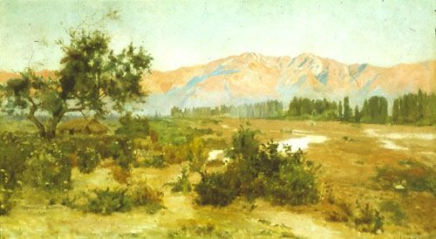

Alberto Valenzuela Llanos, *Paisaje con Cordillera* (*Landscape with Mountains*), 1901, oil on canvas, 56 x 101 cm., Museo Nacional de Bellas Artes, Santiago, Chile

<http://www.surdoc.cl/detalleObjeto.php?id=101542>

In 1901, Valenzuela Llanos travelled for the first time to Europe, with a grant from the Government of Chile, and continued his studies in the Académie Julien, with one of the major exponents of academic style, Jean-Paul Laurens. It was there that he also learned about the modern artistic movements, including **Impressionism** and **Expressionism**. Clearly indebted to the Impressionists’ techniques, such as loose brushwork and the primacy of colour and light, Valenzuela Llanos initiated a second pictorial period. His landscapes gradually moved away from some of the rigid guidelines of academicism, allowing for freer brushwork, natural frames, and more luminous textural atmospheres. As result of his new sensitivity to light, specific elements began to fade in the landscape, lacking the precise contours of his previous work. The paintings that best represent this transition are *Manzanillas en Flor* (*Chamomile in Bloom*) and *Riberas del Mapocho* (*Banks of the Mapocho*). Apart from these landscapes, *Alrededores de Suresnes* (*Around Suresnes*) and *El puente de Charenton* (*The Bridge of Charenton*), among others, with views on Paris, exemplify this shift in his work. Unlike the Impressionists, Valenzuela Llanos did not pursue an art of spontaneity, but produced drawings before painting, applying both perspective and composition. However, the artist did not adhere to the conventions of any particular movement; he instead realised his own balanced collision of styles by synthesizing discordant approaches and interpreting landscape between naturalism and Impressionism, tradition and contemporaneity. In 1906, he returned to Santiago, and in 1910 he was appointed professor at the School of Fine Arts in Santiago, corresponding to the first generation of professors after the decline of the academy and the foundation of the new school. He intertwined his artistic activities with teaching, painting outdoors with the students in the area of Lo Contador, and pursuing a series of landscapes titled after the locality’s name. During these years, Valenzuela Llanos consolidated his career on both sides of the Atlantic, receiving numerous awards, among the most prominent are: Silver Medal, International Exhibition of Buenos Aires (1910), Gold Medal, International Exhibition of Santiago (1910), and Silver Medal, Paris Salon (1913).

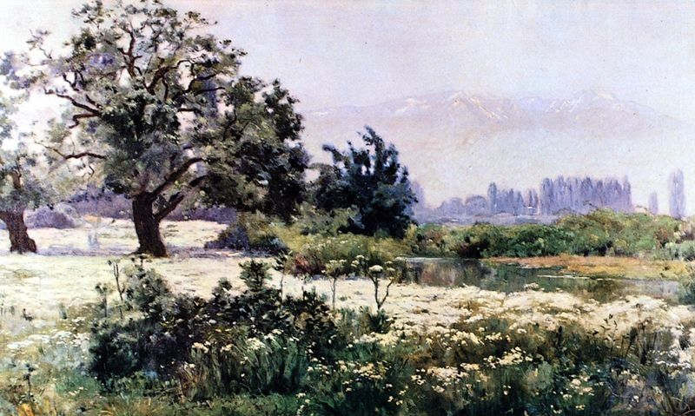

Alberto Valenzuela Llanos**,** *Manzanillas en Flor* (*Chamomile in Bloom*), 1901, oil on canvas, 90 x 200 cm., Museo Nacional de Bellas Artes, Santiago, Chile

<http://www.surdoc.cl/detalleObjeto.php?id=101817>

In 1923, he settled in the Chilean small coastal town of Algarrobo, where he developed a brief but interesting final artistic period before his death in 1925. He painted several views of the coast,achieving a compositional simplicity, synthesis and economy of expressive means. *Dunas de Algarrobo* (*Dunes of Algarrobo*) is an example of this last stage. For Valenzuela Llanos, landscape was a life project and a medium for achieving greater pictorial autonomy. His career culminated in international acclaim. The Government of France gave him the Chevalier Cross of the Legion of Honour in 1923. The following year, he held a solo exhibition with sixty paintings at the Galerie Georges Petit in Paris, and the French state acquired *Romeros en Flor* (*Rosemaries in Bloom*) (then translated into French as “Arbrisseaux en Fleurs”) for the Jeu de Paume; since 1980, it has been in the collection of the Musée d’Orsay in Paris. To commemorate the tenth anniversary of his death, the Museum of Fine Arts in Santiago exhibited a comprehensive retrospective of his work. Ultimately, the Museum of Contemporary Art in Santiago named one of its rooms after him, corroborating the strength of his work and, ultimately, its prevailing conquest over the contemporary.

**Further Reading:**

Alvarez Urquieta, Luis. (1928) *La Pintura en Chile Colección Luis Alvarez Urquieta*. Santiago: La Ilustración. Available at: http://www.memoriachilena.cl/602/w3-article-9500.html

Bindis, Ricardo. (1984) *La Pintura Chilena. Desde Gil de Castro hasta nuestros Días*. Santiago: Philips Editores. Available at: <http://www.memoriachilena.cl/602/w3-article-78761.html>

Bulnes, Alfonso et al. (1935), *Alberto Valenzuela Llanos*. Santiago: Talleres de la Ed. Nascimento. Available at: http://www.documentosartechisle.cl/temas.html?tema=t_muse

Galaz, Gaspar and Ivelic, Milan. (1981) *La Pintura en Chile*. Valparaíso: Ediciones Universitarias de Valparaíso, Universidad Católica de Valparaíso. Available at: http://www.memoriachilena.cl/602/w3-article-8643.html

Museo Nacional de Bellas Artes. (2000) *Chile Cien Años Artes Visuales: Primer Período (1900-1950) Modelo y Representación*. Santiago.

Romera, Antonio. (1951) *Historia de la Pintura Chilena*. Santiago: Del Pacífico. Available at: <http://www.memoriachilena.cl/602/w3-article-9684.html>

Vargas Badilla, José. (1992) *El Pintor Valenzuela Llanos*. Santiago de Chile: Ed. Rumbos.

*Reglamento de la Academia de Pintura*. (1849), Anales de la Universidad de Chile. Santiago: Imp. Del Pacífico. Available at: http://www.memoriachilena.cl/602/w3-article-81299.html

**List of Works:**

Alberto Valenzuela Llanos, *Valparaíso en 1895* (*Valparaiso in 1895*), 1895, oil on canvas, 75 x 110 cm, Private Collection

Alberto Valenzuela Llanos, *Paisaje con Cordillera* (*Landscape with Mountains*), 1901, oil on canvas, 56 x 101 cm.,  
Museo Nacional de Bellas Artes, Santiago, Chile

Alberto Valenzuela Llanos,*Manzanillas en Flor* (*Chamomile in Bloom*), 1901, oil on canvas, 90 x 200 cm., Museo Nacional de Bellas Artes, Santiago, Chile

Alberto Valenzuela Llanos, *Riberas del Mapocho* (*Banks of the Mapocho*), 1910, oil on canvas, 126 x 192 cm., Museo Nacional de Bellas Artes, Santiago, Chile

Alberto Valenzuela Llanos, *Paisaje Lo Contador* (*Landscape Lo Contador*) (date unknown - it entered the MNBA collection in 1910), oil on canvas, 145 x 252 cm., Museo Nacional de Bellas Artes, Santiago, Chile

Alberto Valenzuela Llanos, *Arbrisseaux en Fleurs* (*Rosemaries in Bloom*), 1921, oil on canvas, 76 x 99.5 cm., Musée d’Orsay, Paris, France